**1.) Write a program to swap two numbers :**

**(i) with using third variable**

**(ii) without using third variable**

**(iii) using a function**

**(i)with using third variable:-**

#include<stdio.h>

main()

{

int a,b,c;

printf("\n enter a and b=");

scanf("%d",&a);

scanf("%d",&b);

c=a;

a=b;

b=c;

printf("a=%d\n",a);

printf("b=%d",b);

}

**Output:-**

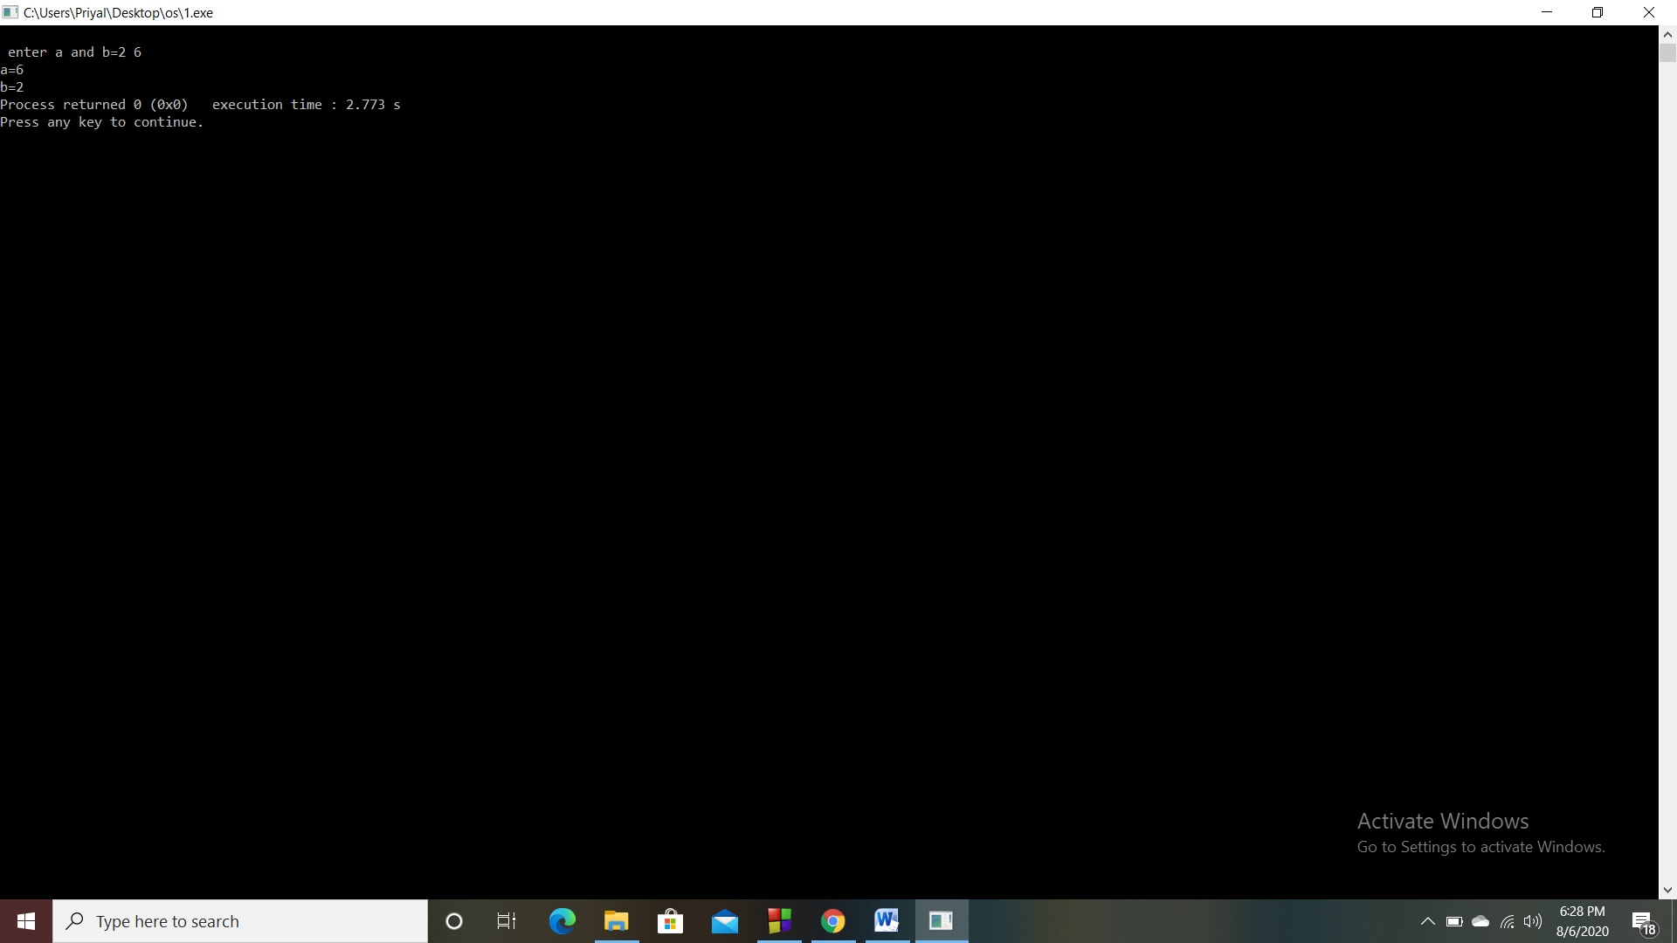

**(ii)without using third variable:-**

#include<stdio.h>

main()

{

int a,b;

printf("\n enter a and b=");

scanf("%d",&a);

scanf("%d",&b);

a=a+b;

b=a-b;

a=a-b;

printf("a=%d\n",a);

printf("b=%d",b);

}

**Output:-**

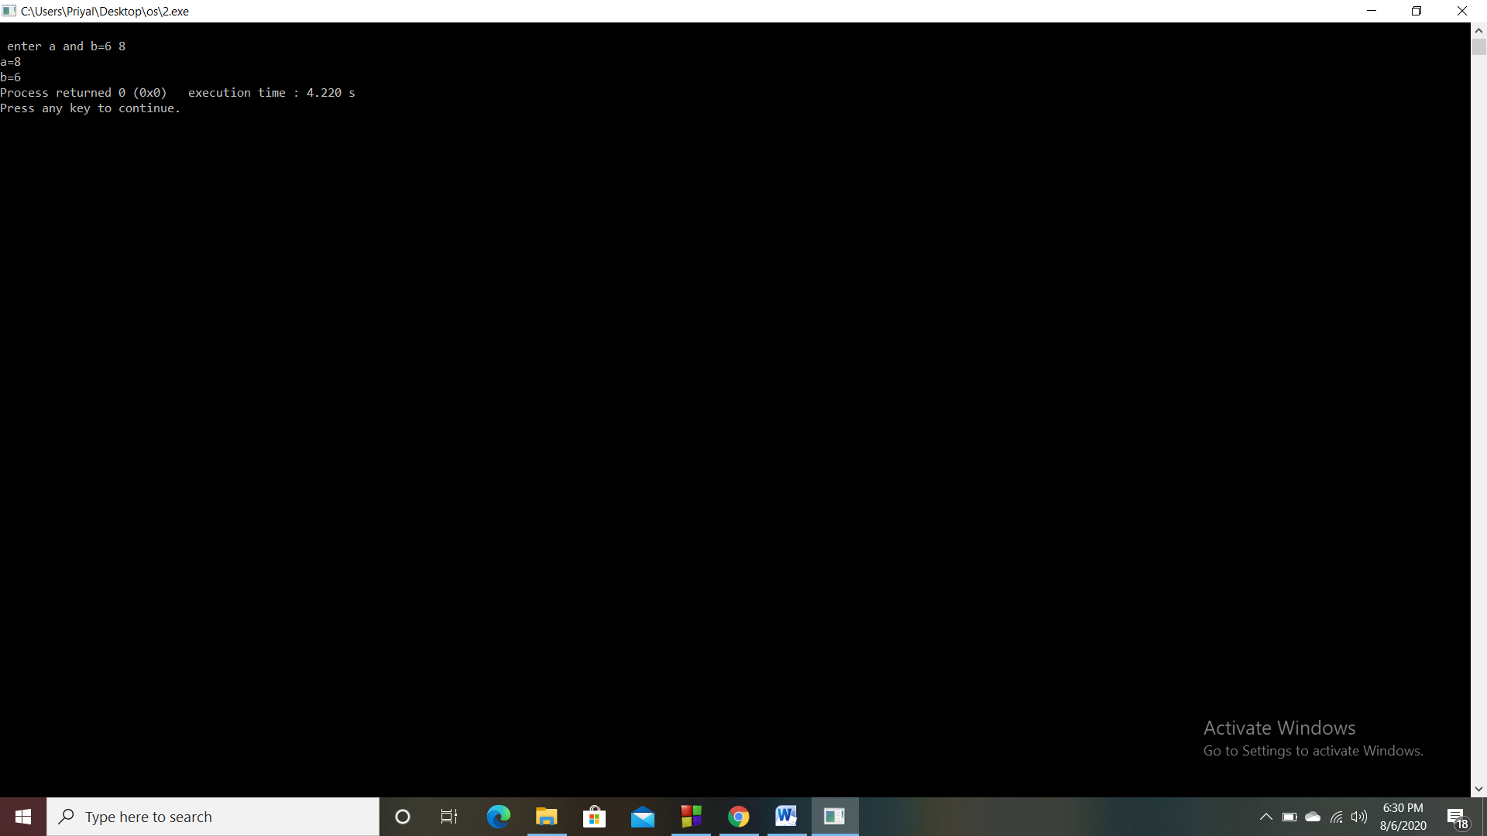

**(iii)using a function:-**

#include<stdio.h>

main()

{

int a,b,ch;

printf("\n enter a and b=");

scanf("%d",&a);

scanf("%d",&b);

printf("\n1.without third variable\n2.with third variable");

printf("\n enter choice=");

scanf("%d",&ch);

switch(ch)

{

case 1: swap(a,b);

break;

case 2: swap1(a,b);

break;

}}

void swap(int a,int b)

{

a=a+b;

b=a-b;

a=a-b;

printf("a=%d\n",a);

printf("b=%d",b);

}

void swap1(int a,int b)

{

int c;

c=a;

a=b;

b=c;

printf("a=%d\n",a);

printf("b=%d",b);

}

**Output:-**

